**Practical No 1**

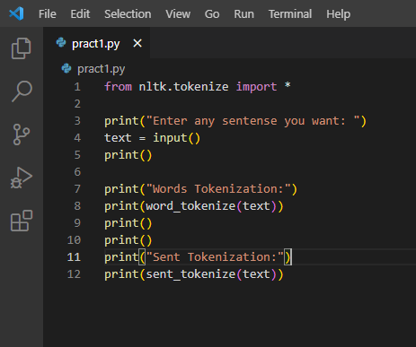

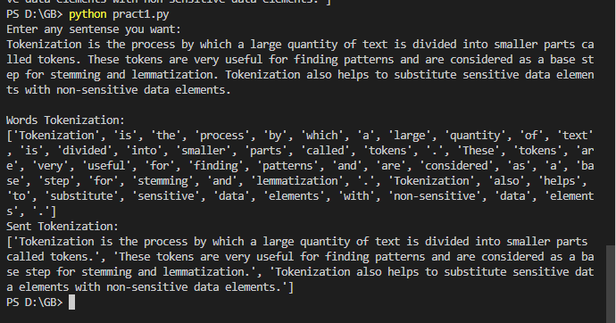

**Practical No 1**



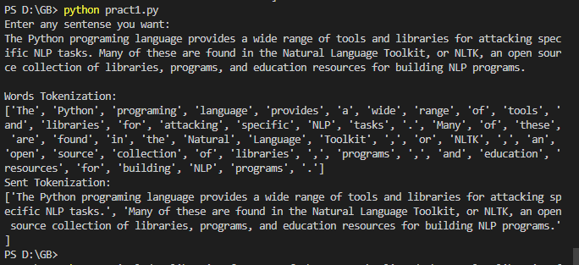

**Practical No 2**

# import these modules

from nltk.stem import WordNetLemmatizer

from nltk.tokenize import *

lemmatizer = WordNetLemmatizer()

# print(lemmatizer.lemmatize("rocks"))

# print(lemmatizer.lemmatize("clocks"))

# print(lemmatizer.lemmatize("books"))

print("Enter any sentense you want: ")

text = input()

txt = word_tokenize(text)

ar = []

def tokenizeee(txt):

    for i in txt:

        w =  lemmatizer.lemmatize(i)

        ar.append(w)

tokenizeee(txt)

print(ar)

for i, j in zip(ar, txt):

    print(i, " : ", j)

-----------------------------------------------------------------------------------------------------------------------------------

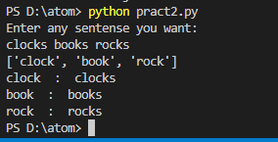

**Practical No 2**

# import these modules

from nltk.stem import WordNetLemmatizer

from nltk.tokenize import *

lemmatizer = WordNetLemmatizer()

# print(lemmatizer.lemmatize("rocks"))

# print(lemmatizer.lemmatize("clocks"))

# print(lemmatizer.lemmatize("books"))

print("Enter any sentense you want: ")

text = input()

txt = word_tokenize(text)

ar = []

def tokenizeee(txt):

    for i in txt:

        w =  lemmatizer.lemmatize(i)

        ar.append(w)

tokenizeee(txt)

print(ar)

for i, j in zip(ar, txt):

    print(i, " : ", j)

-----------------------------------------------------------------------------------------------------------------------------------

